

July 17, 2023

Subject: Country Club Ranches Water Main Improvements Project

(Request for Utility Easement on Private Roads)

Dear Resident:

We hope that this letter finds you well. The City of Miramar as of April 2023 has successfully completed Phase 1 of the Water Main Improvements Project at Country Club Ranches, providing municipal drinking water to 134 residents within your community. Furthermore, as of June 2023, the City of Miramar has entered into agreements to begin construction of Phase 2, and to design and permit Phase 3 of the project.

The Water Main Improvement Project is divided into seven phases. Phase four through seven are identified as being on private roads, which will require the necessity to gain access to the utility easement. These private roads are as follows:

• SW 32nd Avenue

• SW 130th Avenue

• SW 128th Avenue

• SW 126th Avenue

• SW 124th Avenue

Therefore, in order for the City to be able to proceed each home and/or lot-owner will be required to convey an easement toward the Project.

Please note that this process involves legal considerations, surveying, and negotiations with all stakeholders. A Consultant, on behalf of the City, will handle all the paperwork and documentation. The documentation is similar to the easement previously issued to Florida Power and Light (FP&L); please see attached EASEMENT DOCUMENT SAMPLE.

Should you require any further information or have any question, please contact the City’s designated project manager, Eric Francois at efrancois@miramarfl.gov or phone no. 954-602-3309.

Thank you for your attention to this matter.

Sincerely,

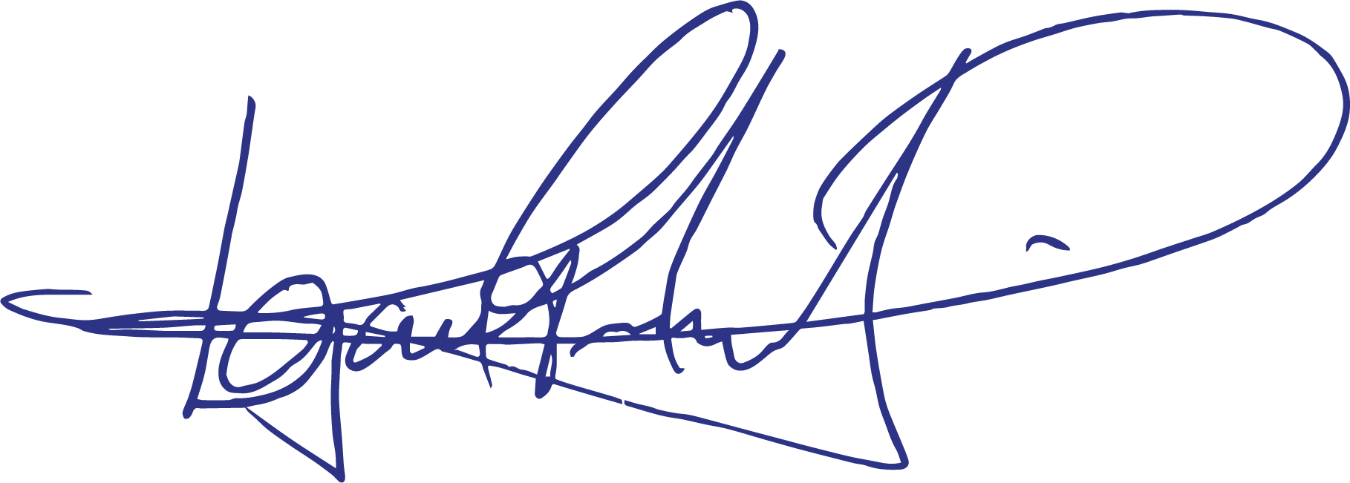

Francois Domond, PE

Director, Utilities Department

**City of Miramar**

An Equal Opportunity Employer

**Mayor**

# Wayne M. Messam

**Vice Mayor**

**Alexandra P. Davis**

## City Commission

**Winston F. Barnes**

**Maxwell B. Chambers**

**Yvette Colbourne**

## City Manager

**Dr. Roy L. Virgin**

### **"We’re at the Center of Everything"**

**Department of Utilities**

Utilities Department

13900 Pembroke Road

Miramar, Florida 33027

Phone (954) 602-Help (4357)