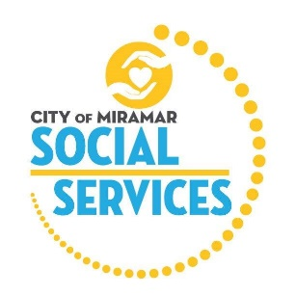

**City of Miramar Social Services**

**Youth Internship Program Description**

This innovative program will educate youth on how their community works together to support its most vulnerable populations. Interns will learn from professional experts in the field of Social Services and how programs are designed to achieve the greatest positive impact for families and the communities in which they live. This opportunity will prepare them for the successes and challenges they will face in higher education, the workplace and in life, all while providing them with a responsibility to improve the world in which they live.

**Youth Interns will:**

* Understand their community’s needs while learning job readiness skills.
* Learn program models for Early Childhood, Adult Day Care, Senior Services, and Youth/Family Outreach.
* Develop Empathetic Understanding, Cultural Competency, and respect for Diversity.
* Understand funding mechanisms, fiscal responsibility, and reporting documentation.

**The Youth Intern program will:**

* Operate Quarterly for 8-10 weeks
* Ensure youth have the opportunity to receive 40-hour of community services.
* Accept 12* students per term
* Immerse interns in multiple departments and varied learning opportunities.
* Host a graduation ceremony to screen student’s final projects

**Internships will begin in September 2023 with a graduation ceremony in November 2023. Applications must be received by September 6, 2023 to be considered.**

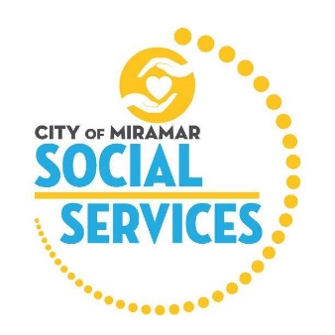

**City of Miramar Social Services: Youth Intern Program**

**Youth Volunteer Intern Job Description**

**Adult Day Care Program**

**Objective:**

Volunteer Interns will develop awareness of the needs of Adult Day Care and how the City of Miramar’s Department of Social Services meets those needs.

**Roles and Responsibilities**

* Work with program administration to learn Adult Day Care policy and Procedures
* Develop an understanding of funding models and how they pertain to adult Day Care services
* Understand the professional disciplines involved in changing levels of client care
* Assist in program’s daily recreational and therapeutic activities
* Create audiovisual report demonstrating increased awareness of program awareness

**Interns will:**

* Be Supervised by the Adult Day Care Superintendent
* Determine specific volunteer hours with assigned staff
* Complete audiovisual project for completion ceremony

**All Volunteer Youth Interns must abide by City of Miramar Volunteer policies and procedures**

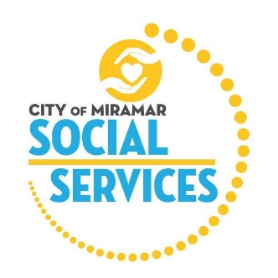

**City of Miramar Social Services: Youth Intern Program**

**Youth Volunteer Intern Job Description**

**Miramarvels Early Childhood Academy Program**

**Objective:**

Volunteer Interns will develop awareness of the needs of an Early Childhood program and how the City of Miramar’s Department of Social Services meets those needs.

**Roles and Responsibilities**

* Work with program employees to learn Early Childhood Policies and Procedures
* Assist teachers with executing activities and lesson plans in the classroom
* Assist teachers in planning and preparing learning center activities for the classroom
* Learn and adhere to all Department of Children and Families and City of Miramar *Miramarvels* Early Childhood program safety regulations and procedures
* Interact and engage in intentional play with the children in their classroom environment appropriately (ex: at the child’s level)
* Shadow Site Supervisor and Early Childhood Leader to learn daily administrative responsibilities as it relates to an Early Childhood program (ex: classroom attendance)
* Work with program employees to learn Federal Food Program procedures and regulations; assist in distributing snacks and lunches
* Create audiovisual report demonstrating importance of early childhood education on children’s futures

**Interns will:**

* Be Supervised by an Early Childhood Site Supervisor and/or Superintendent
* Determine specific volunteer hours with assigned staff
* Complete audiovisual project for completion ceremony

**All Volunteer Youth Interns must abide by City of Miramar Volunteer policies and procedures**

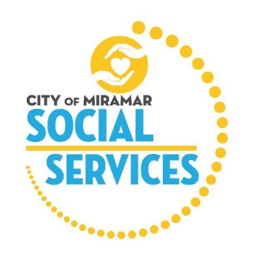

**City of Miramar Social Services: Youth Intern Program**

**Youth Volunteer Intern Job Description**

**Senior Services Program**

**Objective:**

Volunteer Interns will develop awareness of the needs of Senior Citizens and how the City of Miramar’s Department of Social Services meets those needs.

**Roles and Responsibilities**

* Work with program staff to learn Senior Center policy and Procedures
* Interview senior participants and conduct satisfaction surveys
* Assist staff in Recreational and Health and Wellness programming
* Complete required client intakes and daily documentation
* Interview Senior Advisory Board members and understand their role
* Create audiovisual report demonstrating the importance of community programs for seniors

**Interns will:**

* Be Supervised by a Social Services Superintendent
* Determine specific volunteer hours with assigned staff
* Complete audiovisual project for completion ceremony

**All Volunteer Youth Interns must abide by City of Miramar Volunteer policies and procedures**

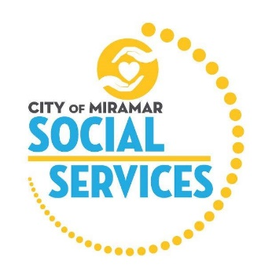

**City of Miramar Social Services: Youth Intern Program**

**Youth Volunteer Intern Job Description**

**Youth and Families Program**

**Objective:**

Volunteer Interns will develop awareness of the needs of Youth and Families, and how the City of Miramar’s Department of Social Services meets those needs.

**Roles and Responsibilities**

* Assisting with client enrollment and assessment
* Understand how benefit eligibility is determined
* Conduct group meetings, workshops, tours, and outreach activities
* Complete required documentation fully and thoroughly
* Work with staff on client records, group notes and other program-related activities
* Interview multi-disciplinary staff to understand distinct roles
* Create audiovisual report demonstrating understanding of community needs

**Interns will:**

* Be Supervised by a Social Services Superintendent
* Determine specific volunteer hours with assigned staff
* Complete audiovisual project for completion ceremony

**All Volunteer Youth Interns must abide by City of Miramar Volunteer policies and procedures**