**Vendor Self Service**

**Step by Step Vendor Registration Process**

<https://mss.miramarfl.gov/vss>

1. Click on login and you will be taken to new registration page to setup account.

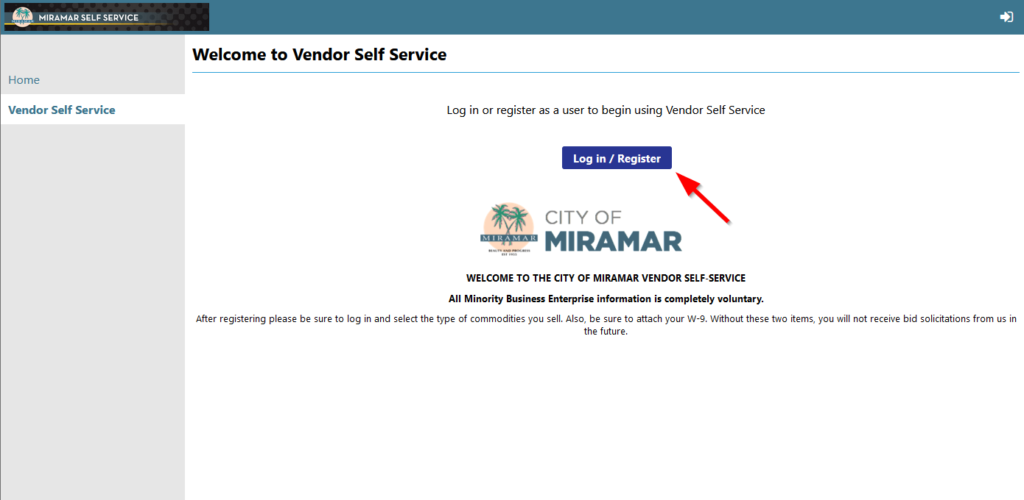

1. Click on Sign up at the bottom.

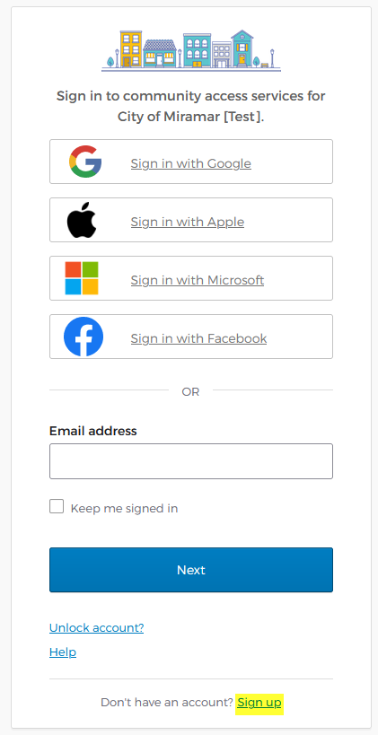

1. Fill out all account details. This email will be used for all future logins

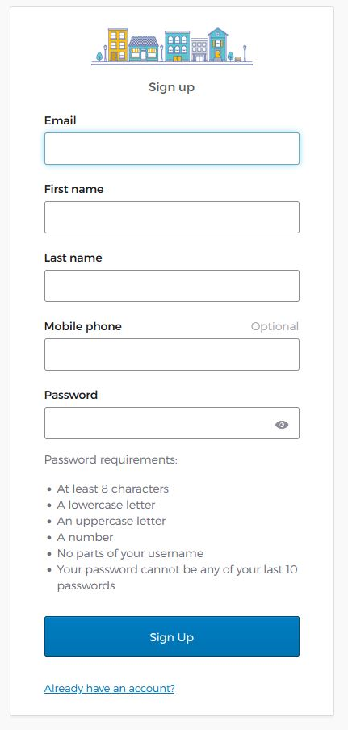

1. You will then be prompted to enter code, which has been sent to the registration email.

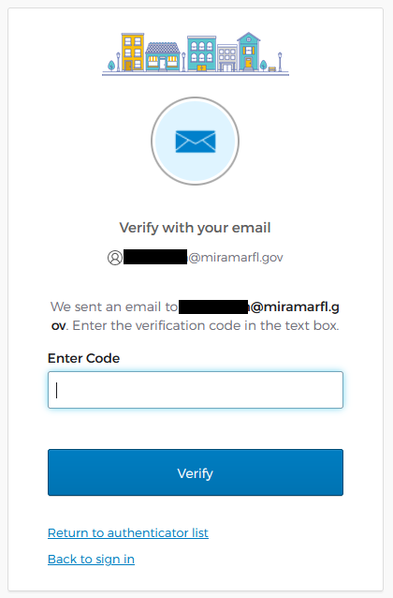 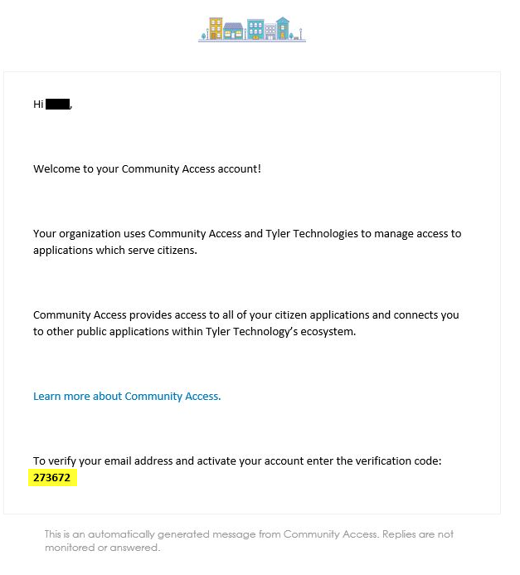

1. After Verifying, you will be taken to the standard Vendor Self Service page where you can link to existing account.

